2 x 10 = 20

2 x 9 = 18

2 x 8 = 16

2 x 7 = 14

2 x 6 = 12

2 x 5 = 10

2 x 4 = 8

2 x 3 = 6

2 x 2 = 4

2 x 1 = 2

Sample Output

2

Sample Input

n x i = result.

Print 10 lines of output; each line i (where 1 ≤ i ≤ 10) contains the result of n X i in the form:

Output Format

2 ≤ n ≤ 20

Constraints

A single integer, n.

Input Format

a new line in the form: n x i = result.

Given an integer, n, print its rst 10 mulples. Each mulple n X i (where 1 ≤ i ≤ 10) should be printed on

Task

learn more.

In this challenge, we're going to use loops to help us do some simple math. Check out the Tutorial tab to

Q1) Objecve

WEEK 6

·

1 + 2 + 4 = 7

·

1 + 3 + 4 = 8

·

2 + 3 + 4 = 9

to be skipped. Thus, the best combinaon is from among:

choosing items 1, 2, 3 -> the sum is 6, which matches the 'unhealthy' sum. Hence, one of the three needs

Given 4 food items (hence value: 1,2,3 and 4), and the unhealthy sum being 6 macronutrients, on

Here's an illustraon:

the sum matching the given 'unhealthy' number.

of their value. Compute the highest total of macronutrients that can be prescribed to a paent, without

'unhealthy' number), and this sum is known. The nutrionist chooses food items in the increasing order

macronutrients. However, the nutrionist must avoid prescribing a parcular sum of macronutrients (an

The nutrionist has to recommend the best combinaon to paents, i.e. maximum total of

incremenng in this fashion.

food item with value 1 has 1 macronutrient, food item with value 2 has 2 macronutrients, and

associated with them. An item's value is the same as the number of macronutrients it has. For example,

line, will have a value beginning from 1 and increasing by 1 for each, unl all items have a value

Q2) A nutrionist is labelling all the best power foods in the market. Every food item arranged in a single

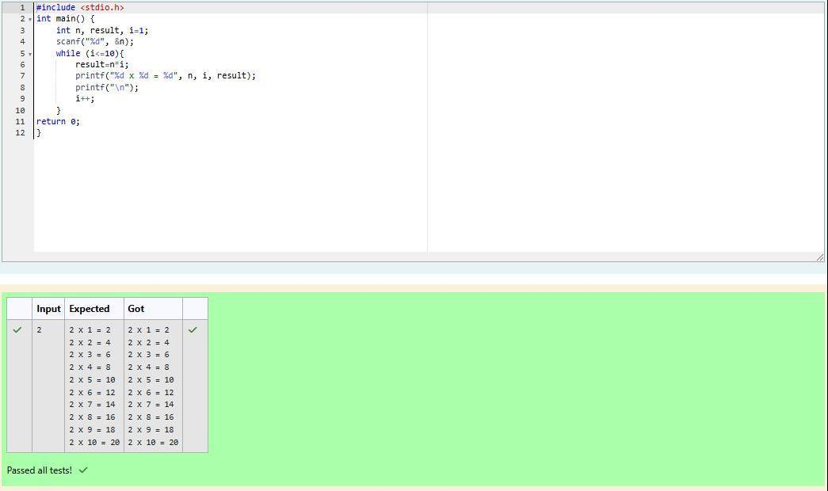

Explanaon 1

2

Sample Output 1

1

2

Sample Input 1

2. 1 + 2 = 3; observe that this is the max total, and having avoided having exactly k = 2 macronutrients.

1. Item 1 has 1 macronutrients.

The following sequence of n = 2 food items:

Explanaon 0

3

Sample Output 0

2

2

Sample Input 0

The second line contains an integer, k, that denotes the unhealthy number.

The rst line contains an integer, n, that denotes the number of food items.

Input Format for Custom Tesng

·

1 ≤ k ≤ 4 × 10

15

·

1 ≤ n ≤ 2 × 10

9

Constraints

k: an integer that denotes the unhealthy number

n: an integer that denotes the number of food items

It has the following:

macronutrients, modulo 1000000007 (10

+ 7)

9

Complete the code in the editor below. It must return an integer that represents the maximum total of

Since 2 + 3 + 4 = 9, allows for maximum number of macronutrients, 9 is the right answer.

2 + 3 = 5, is the best case for maximum nutrients.

Explanaon 2

5

Sample Output 2

3

3

Sample Input 2

Sample Input for Custom Tesng

Sample Case 2

2. Hence, max total is achieved by sum = 0 + 2 = 2.

1. Cannot use item 1 because k = 1 and sum ≡ k has to be avoided at any me.

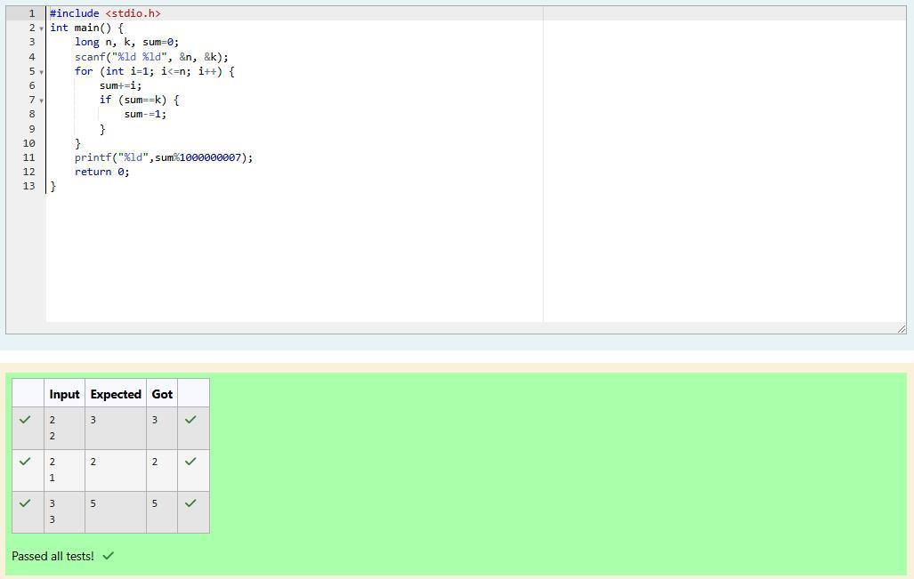

Sample Output 1

5

10

Sample Input 1

Factoring n = 10 we get {1, 2, 5, 10}. We then return the p = 3

factor as our answer.

rd

Explanaon 0

5

Sample Output 0

3

10

Sample Input 0

The second line contains an integer p, the 1-based index of the factor to return.

The rst line contains an integer n, the number to factor.

Input from stdin will be processed as follows and passed to the funcon.

Input Format for Custom Tesng

·

1 ≤ p ≤ 10

9

·

1 ≤ n ≤ 10

15

Constraints

p: an integer

n: an integer

It has the following:

factor of n.

Complete the code in the editor below. The funcon should return a long integer value of the p

integer

th

return 4. If p > 6, return 0.

For example, given the number n = 20, its factors are {1,2,4,5,10,20}. Using 1-based indexing if p = 3,

the p

element of your list, sorted ascending. If there is no p

element, return 0.

th

th

Q3) Determine all posive integer values that evenly divide into a number, its factors. Return

Factoring n = 1 we get {1}. We then return the p = 1

factor as our answer.

st

Explanaon 2

1

Sample Output 2

1

1

Sample Input 2

Factoring n = 10 we get {1, 2, 5, 10}. There are only 4 factors and p = 5. We return 0 as our answer.

Explanaon 1

0

